We are doing the changes in the ADMIN→ Program Locator → Account page.
- Added “Role Name” and User Status filter to have quick access to the list
- Added User Status column in the list - have values like– “ACTIVE” or “PENDING” or ALL
- Added Role Name column to the list - Currently Role Name dropdown have the following values– ALL, Survey Admin, Survey Contact, Network Admin, Network Contact
- Profile Name column is modified to list more than 1 profile name
This is based on our discussion. 1 person can have multiple profile (survey) assigned to him. All the survey related activities have to be done thru ADMIN→ Program Locator → SURVEY Page
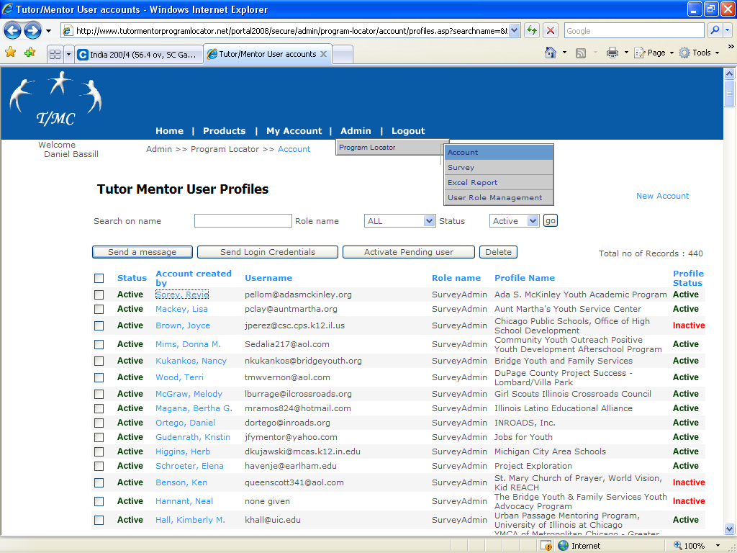
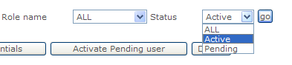
- User Status dropdown have – “ACTIVE” or “PENDING” or ALL
PENDING status – When a user registers, he/she will be placed in PENDING status.
- Network Admin user should be able to select the user (using Check box left side) and click the new button “Activate Pending User” to activate the user – (Currently working on this function)

Comments from Nicole and Chris:
- On Tutor/Mentor User profiles, for all the sites that have Dan Bassill listed as the network administrator, we need to be able to change the network administrator to the actual network administrator for the program with their name and e-mail address without affecting Dan Bassill’s profile.

2) I think one thing that would make updating things easier from our end would be if we could, as administrators, change the login credentials of users (i.e. their email addresses/usernames and passwords). I think that if we could do this, we would get more users updating their info because they wouldn’t have to go through the perceived hassle of creating a new profile and waiting for us to affiliate it with their program; We could just send them a new username and password (that they could then change if desired) and they could update their info after only one email, instead of multiple correspondences. -CW

- Currently working on screen to add multiple profiles/survey to add for a user and also change the users roles - This will be done in “Edit Personal Profile” - We are working on a list box like we have used in OHATS pages to assign multiple surveys

